**CS2850 Operating Systems**

Ref: Modern Operating Systems, Andrew Tanenbaum

**Hardware:**BUS->Controllers -> Peripherals

**Software**-logical apps that run on hardware

**Operating Systems:**- act as a layer between end user app & hardware

**ABSTRACTION:** (Complexity)  
-turns 'ugly' hardware into 'beautiful' abstractions

**VIRTUALIZATION:** (Sharing)

**SECURITY** (& error prevention):  
**User Mode:** (User interface & above)  
subset of instructions  
**Kernel Mode: (**Operating Systems)  
all instructions

**RESOURCE MANAGER:** (Performance)  
Top Down: abstractions to apps  
Bottom Up: manage pieces of complex system, resources allocation

**CPU:**  
- specific instruction set  
- fetches instructions from memory + execute  
- uses registers for storing temp values + control info  
- Modern uses pipeline to ^ perf  
-----while execute, next can decode, following can be fetched  
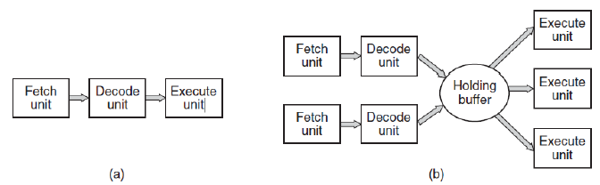  
- Superscalar uses multiple units, ^ power  
- Moore's Law: V size ^ power  
-----Multithreading: diff tasks to take place in CPU  
-----Multicore: several processors  
-----Specialized processors: GPU = small computations in parallel

**Memory:**- not 1 entity  
- hierarchy of layers (costs)  
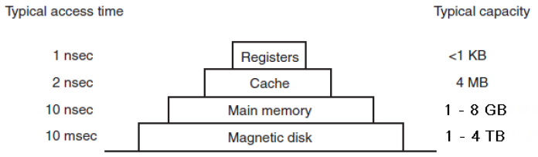

Memory caching (common used mem)  
-L1 : inside CPU - L2: larger than L1, slower (shared)  
------When, Which, which remove, where to put(removed)  
- RAM = main memory (more capacity, even slower)  
- ROM (Read only Memory) programs that does not expect modifications  
- EEPROM (Electrically Erasable Programmable ROM)  
- CMOS (Complementary Metal-Oxide Semiconductor) batt , time/date, config params  
- Flash (slower than RAM, write = wear out)  
- Magnetic (much slower) (surfaces and RW heads)  
- SSDs (no moving parts, flash) *Hybrid  
- Virtual Mem (not enough mem, disk space used to temp store info)

**I/O input output:**- controller (hardware accepts command from OS) and device (e.g. SATA disk controller)  
- each is different (min complexity, abstraction) and have device driver (created by vendors)  
**“busy waiting”**1. Program issue system call  
2. OS translate call to device driver  
3. Driver initiate I/O and continuously poll, check done  
4. Returns result. OS pass to caller (prgm)  
X = OS is busy waiting for poll  
- alternative = **INTERRUPT** initiate request, and ask to be notified when it’s done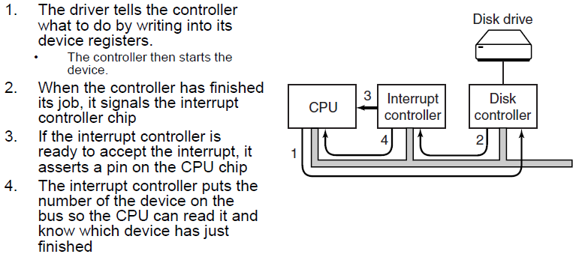  
- Use an interrupt controller to inform the CPU  
- Interrupt controller manages several apps  
- taking the interrupt, run the handler, return to user program (don’t want another interrupt ,therefore handlers must be small)

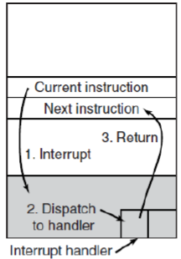  
- Direct Memory Access (DMA)  
Control flow btwn MEM and controllers   
CPU tell DMA bytes to transfer, memory, direction  
--offload expensive memory operations

**Buses**PCIe, USB, DMI, SCSI

**Operating Systems:**server, personal, handheld  
Processes  
= a program in execution  
--- associated with address space, resources  
--- container, holds all info to run prgm  
--- process tree, can create child process  
- Files (pointers to file)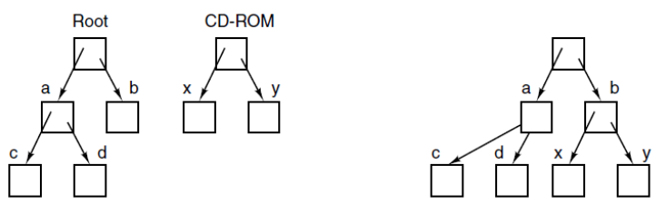  
process connected by pipe (1R, 1W)

**Process**

OS = support multi programs  
- PID, name, User, EXE file, registers/vars/counters  
- process = abstraction of running program

**Pseudo-parallelism  
-**switch process to process, allow “simultaneous”  
-one program = active at once (in a single core)  
- concept of independent = sequential process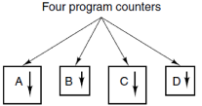

**Process Creation**1. Sys init  
2. Execute “process creation” sys call by running process  
3. A user request to create new process  
4. Init of a batch job  
**Create new process = POSIX = fork**1. Clone created  
2. Parent + child = same copy of memory, env, resources  
3. Address space = separate  
* child can change mem and run a new program  
**Create new process = WIN = CreateProcess**1. Process created  
2. Init exec  
*address space = separate  
**Process Termination**normal exit, error exit, Fatal exit, Killed

**Process Types**- Directly interact with users  
- Backgrounds, react to occurrences = daemons

**Process States**1. Running – using CPU  
2. Ready – Runnable, stopped by others  
3. Blocked – unable to run, some external events hap  
**Transitions**1.R-B Process blocks for input  
2. R-Re Scheduler picks another process  
3. Re-R Schedulers picks this process  
4. B-Re Input becomes avail  
Lowest layer = interrupts + scheduling  
above layer = seq process

**Process Implementation**- typical fields = priority, CPU time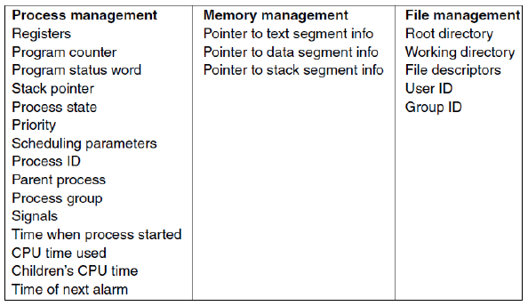  
- Skeleton of what the lowest level of OS does (interrupt)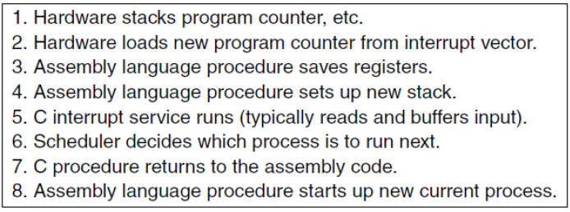  
**Multi-programming**CPU utilization  1 − *pn*  
where p = probability of process waiting for I/O  
where n = number of process in mem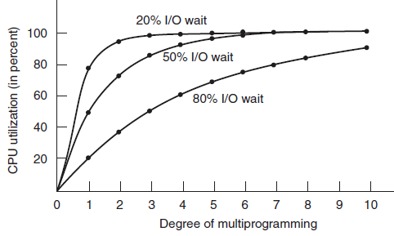

**Threads**

= mechanism is sometimes more desirable

Having parallelism whist sharing address space

Thread = component of a process, and a process can have multiple threads running in parallel

**Why?**

Less overhead  
Context switching = faster  
same address space = easier to code that requires interaction

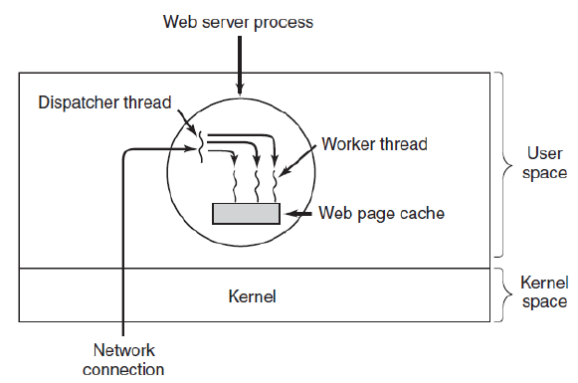

Dispatcher Thread Worker Thread

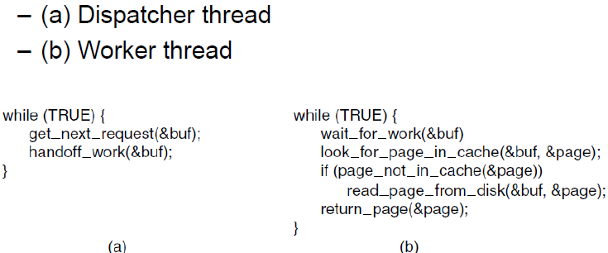

3 process with 1 thread 1 process with 3 threads

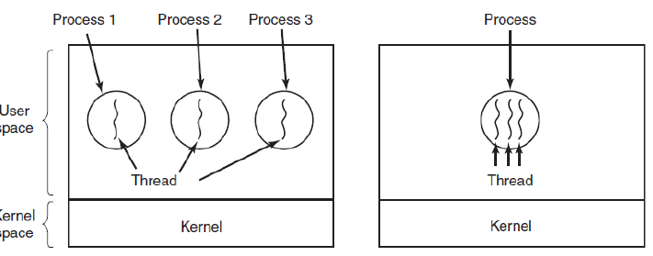

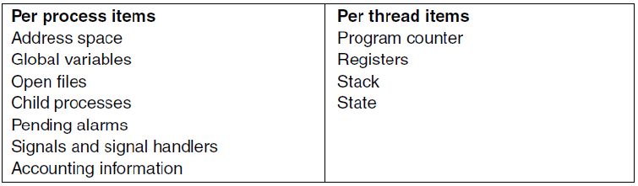

**Thread States**

1. Running
2. Ready
3. Blocked

**Thread Creation**

Process started, 1 thread present

1 thread creates new one by calling lib function

* Calling thread gets an identifier for new thread

**Thread Termination**

Via lib call

Scenarios = analogous, to terminate

Allows threads to wait for each other to finish, then join

**POSIX Threads**

Standard API ->thread management (Pthreads)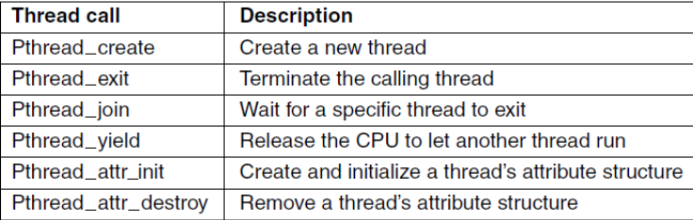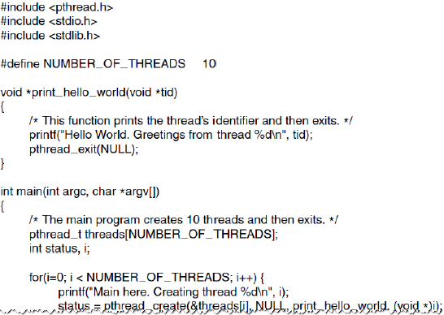

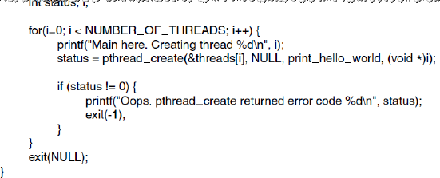

**Implementing Threads**

User level threads Threads managed by Kernel

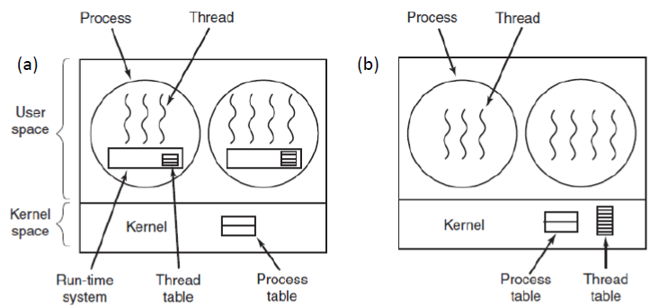

**User-level threads**

* Kernel not aware
* Implemented on OS with no thread support
* Context switching = simple + fast (local calls)
* Scheduling = customizable
* Blocking system calls interfere schd(page faults)
* Relies on threads giving up CPU voluntarily
* Many reasons of using threads are to take adv of blocking calls to run other activities

**Kernel-level threads**

* Has a list of threads, like list of process
* Blocking system calls = transparent
* New unblocking not required
* Page faults by 1 thread do not affect others
* System calls = costly
* Multithreaded process fork semantics
* Signal handling – which thread takes a signal

**Hybrid Popup**

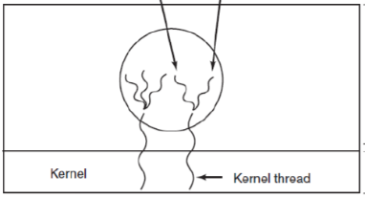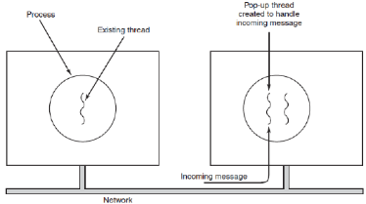

**Making Single=T codes Multi-T**

Issue = conflicts using global var

Solution = can have private global var (T1_var)

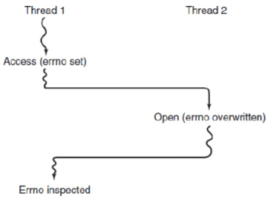 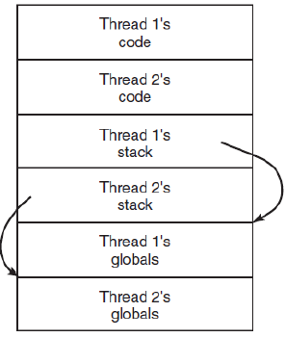

Other issues:

* Non re-entrant lib procedures (called whilst still in exec by another thread)
* What if? Loses CPU during mem alloc
* Address signals?

**Inter Process Communication**

* Pass info relevant to multi-process task
* Prevent attempts to access exclusive resource simultaneously
* Work an appr seq of events when have dependencies

Threads share mem, Process share common storage

Potential issue = **Race condition**

2 or more process R/W shared data at the same time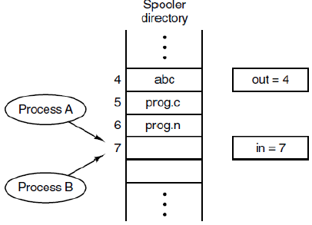

Parallelism = ✓, but increase chance of race condition

Debugging = hard, only some situation happen occasionally

**Mutual Exclusion** = technique to avoid race condition

1 process use, other process are excluded

Identify parts that access shared resources **critical region** and prevent more than 1 process from access

**Critical Region**

1. **No 2 process** can simultaneously inside
2. **No assumptions** made on speed/no. of CPUs
3. No process outside CR may **block other** process
4. No process should **wait forever** (CR)

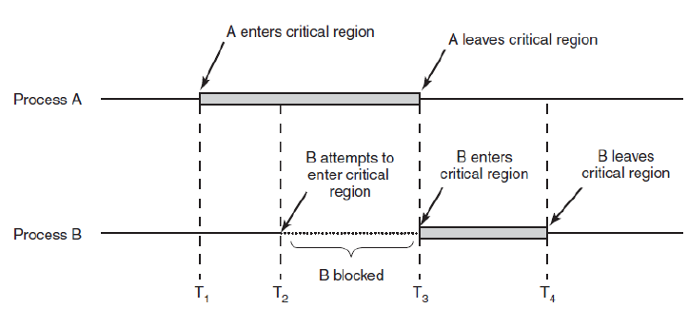

**BUSY WAIT**

= 1 proc is busy updating shared mem in CR, no other proc will enter CR and cause trouble. Will keep waiting

**Lock Variable**

* Variable set to 0
* Locks it (change to 1) Unlock (change to 0)

Problem – read and write are diff instructions (can be interrupted)

**Strict Alternation**

“turn” variable

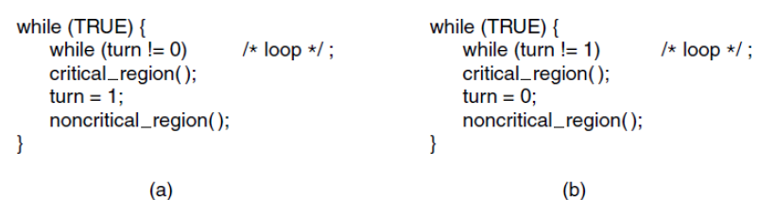

Problems

Only applicable when wait is short

<a> is much slower than (b), (b) waits a long time

🗶 “No Proc running outside CR may block other proc”

**Peterson’s Solution**

Idea: indicates interest, but offer others to go first

CR Control:

Enter_region(process);

Critical_region();

Leave_region(process);

Before entering, proc calls with its own no. (0 or 1)

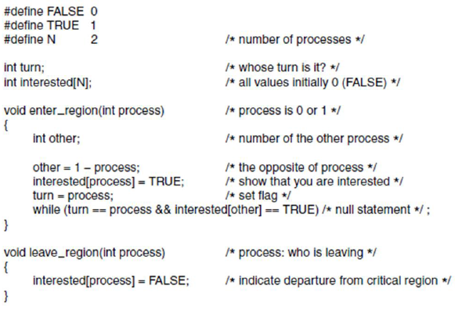

**Proof by Contradiction**- P0 entering, when P1 is already   
(interested[other] = true, so P0 can only enter if turn = 1, but P0 just change turn = 0.)

-P1 entered when turn = 1, P0 is entering  
(interested[0] = true before setting turn = 0 , so P1 should be waiting in a loop)

**Proof of No Mutual Blocking**

* Impossible, cause turn is either 1 or 0

(will become false, one will enter)

**Condition 4 (wait forever)**

* 1 process wait forever (when leaving, it sets interested[other] to FALSE, the other one can enter)
* Turn = offer turn to another process

**Hardware: Disabling Interrupts**

* Simple
* But must give privileges
* If got bug, process = never enable interrupt
* Does not work for multiprocessors

**Hardware: The Test and Set Lock Instructions**

CPU provide commands (several actions at a time)

* Atomic, no interrupts
* TSL allows us to construct a safe version of lock
* Enter and leave using TSL



XCHG – in X86 system

* Hardware routines = simple, easy to verify
* Any num of process at no extra cost
* Still involves busy wait

**Problems with busy wait**

* CPU time wasted
* Priority Inversion Problem
  + L is in the CR
  + H wants to enter
  + H takes up CPU to keep checking, L no CPU to check and vacate CR
  + = DEADLOCK

**IPC without busy wait**

Mutual exclusion without busy wait!

**Sleep and Wakeup**

* sleep = suspends process
* wakeups = awaken process
* **sleeping does not waste CPU time**

**Producer-Consumer Problem**

* 2 processes communicate through a common fixed size buffer, 1 put info, 1 reads n take out
* PRODUCER = new item, buffer = full
  + Try busy wait (wants to avoid)
  + Go to sleep until buffer has space
* CONSUMER = new item, buffer = empty
  + Try busy wait (wants to avoid)
  + Go to sleep until new item comes
* FATAL RACE CONDITION
  + Due to several machine instructions, both goes to sleep
    - C reads as 0 (prepare to sleep)
    - <interrupted>
    - P places item, buffer =1  
      tries wake up C (still awake)
    - C continues, (goes to sleep)
    - P continues (goes to sleep)
    - EVERYONE SLEEPS!!!!!

**Solution: Semaphores = special variable**

* Keep info about no of wakeup calls which not taken into account
* Allow 2 main ops
  + Down – if 0 = sleep, or else decrement and allow execution
  + Up – increment (if got process sleeping due to down, 1 will be awaken to execute)
* Check value with atomic operation
* Once started, no other process can access
* Implemented as sys call:
  + OS disables interrupt
  + Multiple CPU, protect semaphore lock var with TSL/XCHG
    - Some busy wait, BUT **limited for very short semaphore calls instead of whole CR**
* 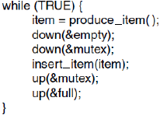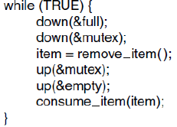
* Used for Mutual Exclusion
  + Protect a CR, preventing race condition
* Used for synchronization
  + Prevent/force a certain seq of events
* Binary Semaphores = 2 processes only

**Mutex – simplified semaphores**

* Locked or unlocked
* Efficiency
* Implemented in User space
  + (up/down instructions = kernel)
* Mutex_lock = down
* Mutex_unlock = up
  + No count kept
* Condition variables (blocking threads, based on conditions) = allow adv scenarios
  + Allows additional checks with less codes
  + Acts as a count value

**Monitors**

Collection of procedures, var, data struct, group in mod

Processes can call procedures in monitor, not data struc

1 process can be active in a monitor (mutual exclu)

* Computer will generate necessary instructions

CR can turned into monitor (for mutual exclu)

In Java, class that use *synchronized*

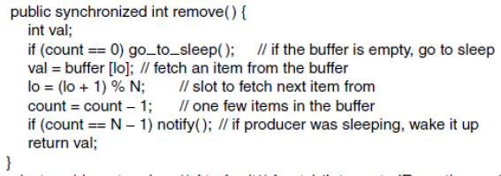

**Message Passing**

Distributed Systems = cannot for semphores/monitors

IPC using sys call = send receive(any source)

Process invoking receive gets blocked if no message ava (or return with error code)

**Challenges:**

* Communicate via network (msg can be lost)
* Can use protocol (like TCP)
  + Ack, Retransmit
* >1 machine = need authentication
* Performance also = send message more time

**Barriers**

Applications rely on phases

Phases separated by **Barriers** (must all process ready, then go next phase)

Synchronization mechanism



**Avoiding Locks: Read-Copy-Update**

Insert node in tree, then remove branch, then connect





**Classical IPC Problem**

**Dining Philosophers Problem**

5 ppl sit in a circular table (5 spag, 5 forks) 

Spaghetti eating with 2 forks

Ppl = eat/think

If hungry = pick up 2 fork, then eat, then go back think

NONSOLUTIONS:

* Random time
  + Non always applicable (Critical sys)
* Mutex
  + Down before request, up after releasing
  + 1 philosopher can eat

Starvation = continue to run but fail to do progress

**Deadlock-free solution while maximizing resource usage**

* store state for all (eating, thinking, hungry)
* can eat only if non immediate neighbors are eating
* array of semaphores to block hungry philosophers that cannot eat yet

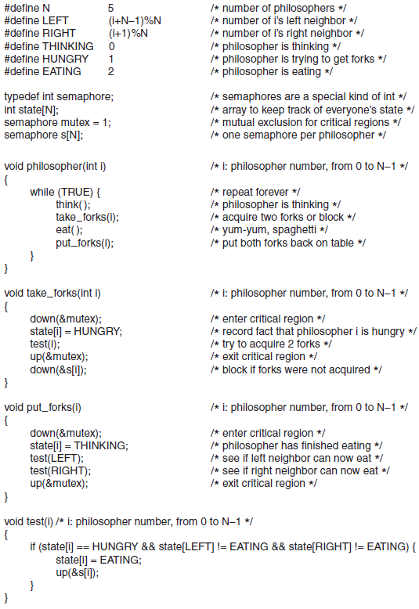

**Readers and writers Problem**

Consider a database

2 processes: readers and writers

Any numbers of readers can read

When writer write, no one can read

Non - Solution:

* Last reader, free up CR
* Writer writes when its free
* However, writer might wait forever.
* Reader’s priority

**Scheduling**

**Types of Scheduling**

Admission Scheduling

* Long term, used in batch sys

Memory Scheduling (which/when should be swapped)

* Medium term
* Used in all

CPU scheduling (which process to run next)

* Short term
* Used in all
* Make efficient use of CPU   
  (process switching = expensive)
  + User to kernel
  + Save the current process state
  + Save memory map for current
  + Select new process
  + Load memory map for new process
  + Place new process into exec

**Process Behaviour**

Alternative bursts with I/O requests (disk/network)

**2 types:**

* CPU-bound (use mainly CPU)
* I/O-bound (mainly wait I/O)

When? (to schedule)

* On process creation: parent/child?
* On process termination
* On process blocking (I/O, semaphore)
* I/O interrupt
* Periodic clock interrupt

Scheduling Method Classes

* Non-preemptive scheduling   
  (voluntarily release CPU)
* Preemptive scheduling   
  (let it run with a max fixed amt of time)
* Diff = use clock to exchange memory

**Categories of scheduling algo**

* Batch
  + Payroll, etc
  + Doesnt require user interaction
  + Non preemption, preemption if time is allowed
* Interactive
  + Preemption = prevent one process sticking with CPU
  + Servers also (serve multiple users)
* Realtime
  + Counter intuitive, preemption not needed as process usually do not run for long period (work and block quickly)

**Scheduling Algo Goals**

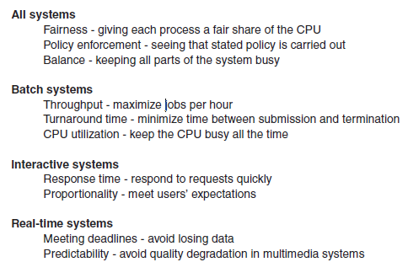

Scheduling in Batch Sys

* 1st come 1st serve
  + Queue
  + Not efficient
* Shortest Job first
  + If you know hw much time
  + Shortest turnaround time
  + Optimal = if available simultaneously

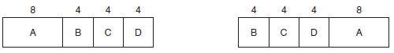

* Shortest Remaining Time Next
  + If you know how much time
  + Preemptive of SJF

**Scheduling in interactive systems**

Round-Robin

* Each process assigned a time interval (quantum)
* If blocked, then switch
* Easy to implement
* If quantum = too short = too many switches

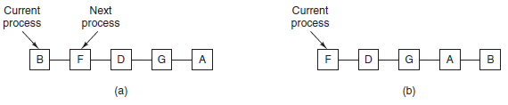

Priority

* Jobs =/= same importance
* Selected = highest priority
* Scheduler decreases priority every switch at clock (prevent highest to keep running)
* Use quantum and max time the highest can run

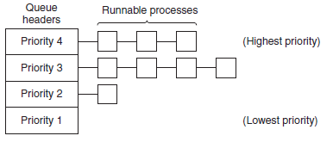

Multiple Queues

* Queues with priority
* Drops priority if used up allocated quanta

Shortest Process Next

* Estimation required
* (similar to non-preemptive batch)

Guaranteed Scheduling

* Give certain level of service according to resources
* Promise amount of time to a process
* Requires logging

Lottery Scheduling

* Important process gets more ticket
* Cooperating process can exchange ticket
* Random

Fair-share Scheduling

* To prevent users have more process
* Take into account process owner
* Each user allocated a fraction of CPU time

**Scheduling in Real-Time Systems**

Time = essential role

3 categories

* Hard real time
* Soft real time
* Period/aperiodic

Sys may not be able to handle all, unless the sum of all process time <= the total CPU time

**Policy VS Mechanism**

Scheduler = limited info

(process have relevant info how it should schd)

Separate scheduling mechanism from scheduling policy

* Algo can be parameterized
* Process can input priorities
* Scheduling mechanism = kernel

**Thread Scheduling**

* 2 types (user/kernel)
* User = scheduler controls scheduling process, threads scheduled own process
* Kernel level = scheduled as a process
  + Block thread =/= block owner process

(Context switch are more costly)

**Memory Management**

Needs to be managed due to size speed, volatility, cost

* MB of very fast, expensive, volatile, **cache**
* GB of medium speed/priced, **main mem**
* TB of cheap slow **SSD/HD**
* Removable (DVD)

Concept of memory hierarchy = important   
(memory management)

**Running >1 programs without memory abstraction**

* Swapping: save the entire contents of mem to disk, load the next program
* Divide memory into chunks (prevent illegal access)
* Static relocation: change programs on the fly change the accessed memory address
  + Slow + complex

**Relocation Problem**

Jumps to specific address (if relocated, then messed up)

**Memory Abstraction: Address Space**

* Protection
* Relocation

**Address space**

* Abstract memory
* Each process has its own address space

**Base and limit registers (dynamic relocation)**

* Programs are loaded where there is room
* When a program starts
  + Base register is loaded (physical address)
  + Limit Register is loaded with the length
  + Every time loaded, Base+limit loaded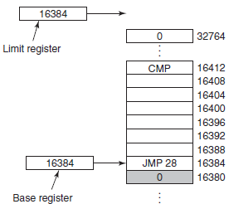

**Swapping (physical memory not sufficient)**

Bring process back, Run a while, put back to disk

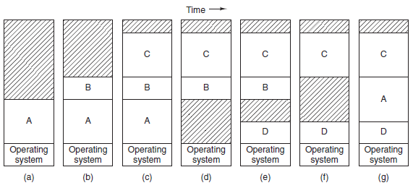

Process can grow, (allocate abit more, so no need force swap)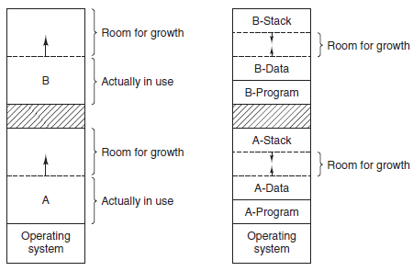

**Bitmaps**

Memory is divided into allocation units

Each allocation unit is represented by bit in bitmap, free or not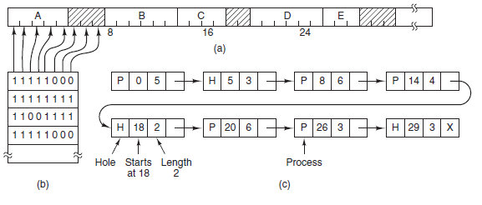

* Smaller allocation unit, larger bitmap
* Large allocation unit = waste memory
* Simple, but consecutive empty units search = slow

**Linked Lists**

Maintain a linked list of allocated and free memory segments

Segment list can be kept sorted by address

Easy to swap and terminate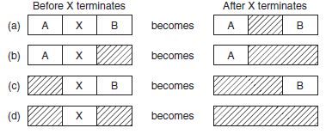

**Memory Management Algorithms**

**First Fit**: find first hole that is big enough

Broken into 2 pieces, 1 for process, 1 for unused memory

**Next fit**: Scan from last segment where it found a hole

(worse performance based on simulations)

**Best fit**: Smallest hole that fit (scans whole list, slower than first fit)

(slower and waste memory, a lot of small tiny holes)

**Worst fit**: Largest hole that fit (not good also)

* Algo need to scan holes
* Uses added time to move segments between lists when process terminates or swap

**Quick fit:** separate list for more common sizes

* Merging = hard

**Virtual Memory**

Run program that are too large

Then, split programs into little pieces (**overlays**)

* Kept on disk, swapped in and out
* Require programmer to design

Solution: **Virtual memory (pages)** managed by OS

**Page**

Contiguous range of address

Pages are mapped onto physical memory

(not all need to be mapped at the same time)

Prgm references (hardware perform mapping on the fly)

**Paging**

* Virtual addresses and virtual address space
* MMU = maps virtual to physical
* Page table = Relationship (of virtual & physical)
* Page = 4096 (ends 4095 higher)

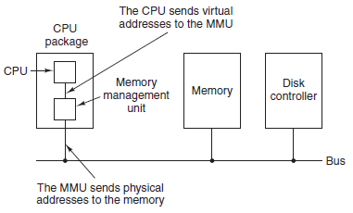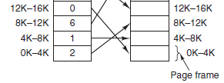

**Page fault** = MMU notices unmapped and causes the CPU to trap to OS

OS saves a page to the disk

Map updated, trapped instruction is updated

**Internal operation of MMU**

-virtual page no. is used as **index** into page table to find entry for virtual page

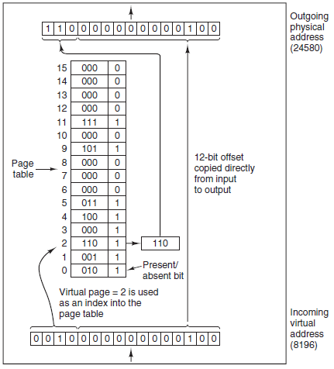

**Page Table Entry**

* Protection: 1 bit for r/rw or 3 bit for r|w|x
* Modified: (changed after loaded)dirty/clean
* Referenced: check if referenced, useful to determine which pages are evicted

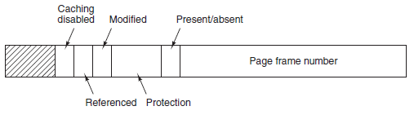

**Major Issues (speeding up pages)**

1. Mapping virtual to physical = must be fast
2. Virtual address is large = page table is large = (slow to scan)

Observation

* Most program = large no. of references to small no. of pages
* Small fraction of page table entries mostly read

**Translation Lookaside Buffers (TLB) = speed paging**

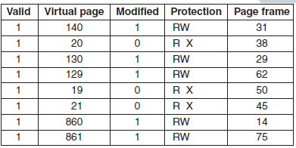

**Multilevel Page Tables (**very large virtual address)

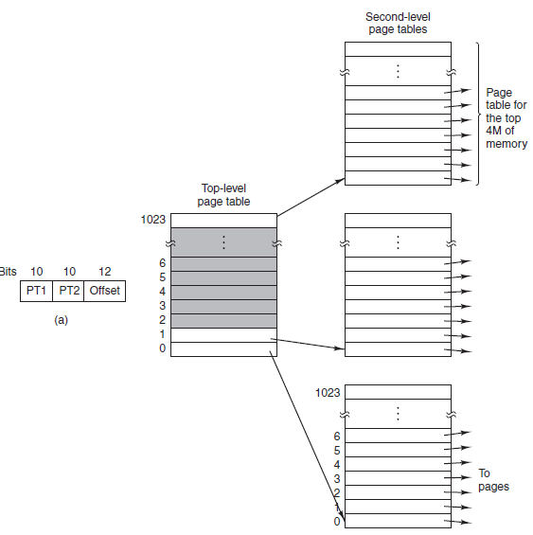

**Inverted page table**

To prevent many levels, page table can have one entry per frame in real memory (1GB RAM, 1GB TABLE), instead of one per virtual page

* Saves space
* Virtual – to-physical becomes harder
  + TLB can minimize
  + Possible to have hash table hashed on virtual address

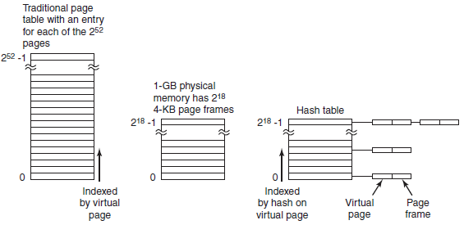

**Page Replacement (page fault)**

Optimal Algo

* Page with highest label to removed
* Each labeled with no. of instruction until ref.
* UNFEASIBLE = can’t predict future ref.
* Used for benchmarking.

Not recently Used Algo

* System inspects pages (Ref, Mod)
* NRU with the lowest class
* Class 0: Not ref, Not mod, .., Class 3: ref, mod

FIFO Algo

* First entry memory, first exit
* New page added at end of queue
* Problem = oldest page still useful

Second Chance Algo

* Sorted in FIFO
* If useful, queue again in FIFO

Clock Page Replacement Algo

* More Efficient than 2nd chance algo, does not move pages
* Move arrow (like clock), has R value to show can evict or not

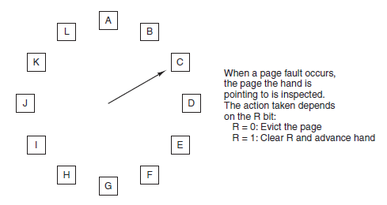

**Least Recently Used Algo**

Throw away page that has been unused for longest (based on observation)

Expensive = needs all pages and access time

Simulating LRU Algo = Aging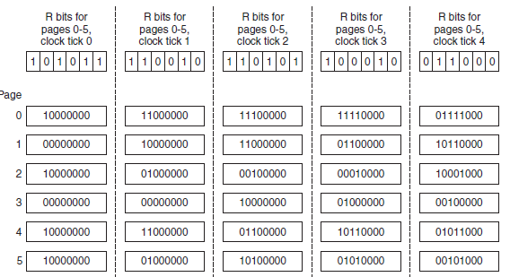

**Working Set** (pages that a process is currently using)

- Purest form, no pages in memory

- **Demand paging** = fetches all the stuff required to run, settles down and few page faults after some time

**Locality of reference** (at any phase, process references small fraction of pages)

Paging system can load the current working set once a process gets swapped back into physical memory **(working set model, prepaging)**

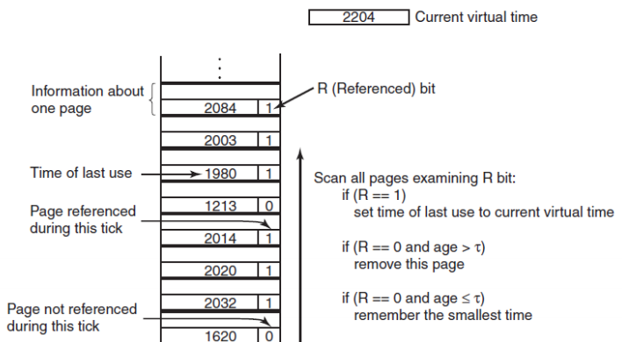

WSClock

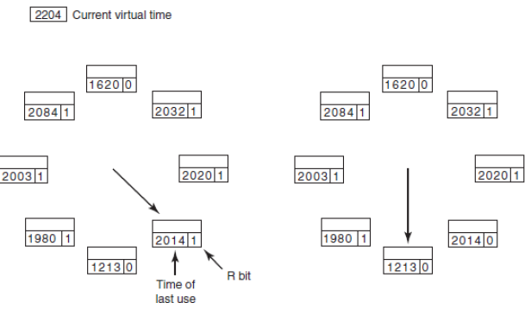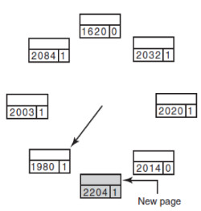

Summary

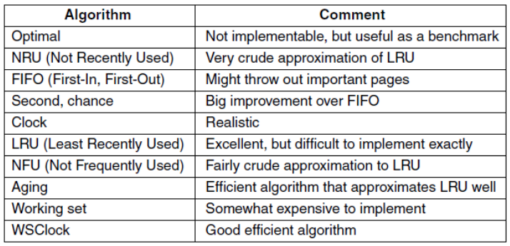

Local VS Global Allocation

* Original configuration
* Local page replacement
* Global page replacement

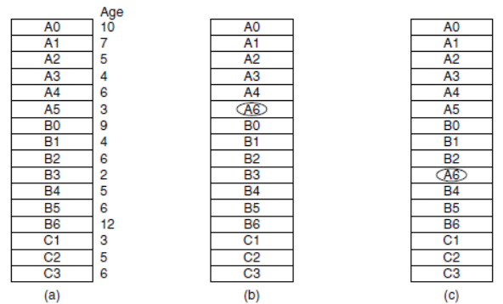

Separate instruction and data spaces

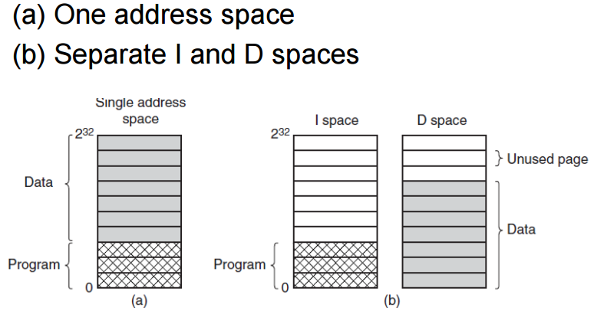

**Shared Pages**

2 processes sharing same program sharing same page table

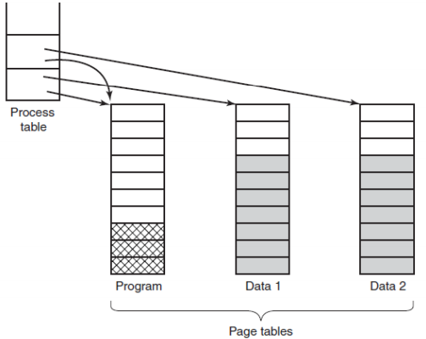

**Shared Libraries**

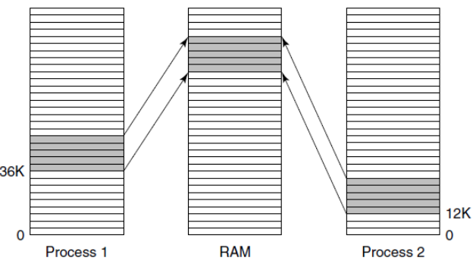

Page Fault Handling

* Traps to kernel, save program counter on stack
* Save general registers and other info
* System discovers page fault, tries to discover which virtual page needed
* Once found, checks address validity and protection is ok
* If dirty = transfer to disk, and context switch
* If clean, brings it in
* Disk interrupt when page arrived table updated, frame marked as normal
* Fault instruction backup up, program counter reset
* Faulting process scheduled, OS returns to routine that called it
* Routine reloads registers and other state info, user space continue execution

**Backing Store (SWAP)**

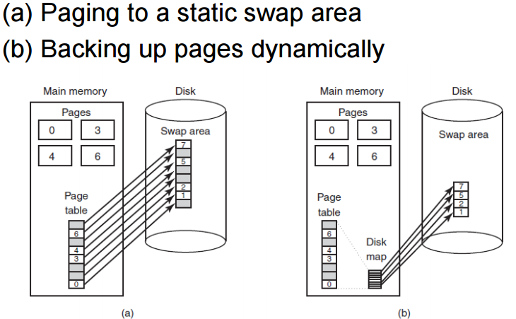

**Segmentation**

Program = Store separate groups of data

Set segments with growing tables:

* Source text
* Symbol table (name and attributes of var..)

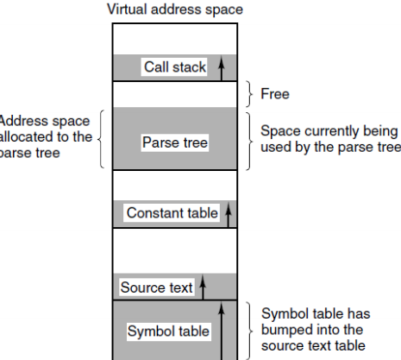

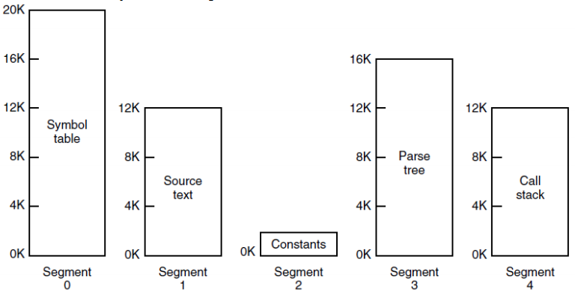

Can grow and shrink independently

**Segmentation VS Paging**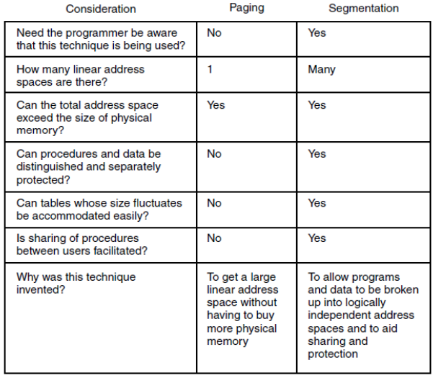

**Segmentation WITH Paging: MULTICS**

Segment descriptor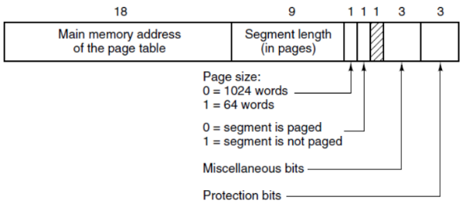

**Segmentation WITH Paging: INTEL x86**

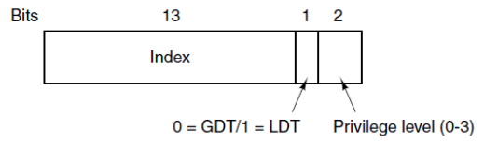

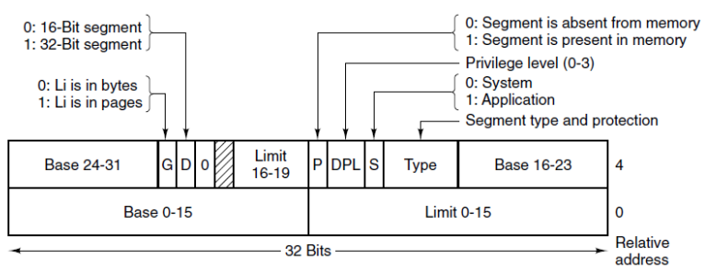

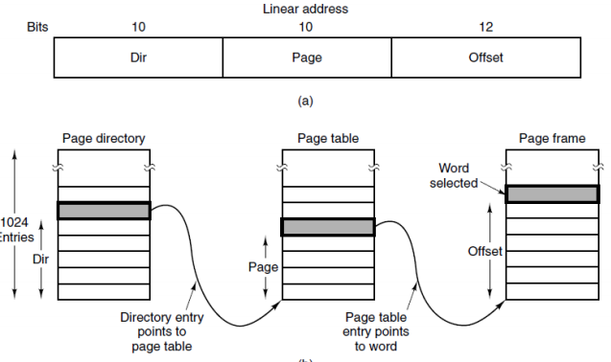

**File Systems**

Need for file storage

* process have limited amount of space to keep data (virtual address)
* process terminates, information lost
* multiple process need to share data

Requirements for long term storage

* possible to store very large amount
* survive termination of process
* Multiple process access information at once

Simplified: Read/Write

But:

* How to find info?
* How to keep one user from reading another user data?
* How to know which blocks are free?

Concept of file = OS Abstraction

Files = logical units of information created by process

Information stored in files = **persistent**

(Process creation and termination does not affect)

OS component = **file system**

**File Naming (depends on OS)**

Main_name(.)extension

**File Structure**

* Unstructured sequence of bytes (OS don’t care)
* Files that contains fixed-length records (old)
* Files that has Tree of variable-length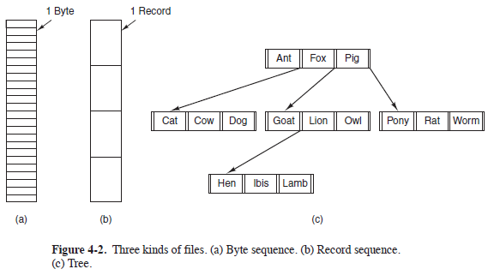

**File Types**

OS support different types

* Regular files (contain user data)
* Directories (maintain structure)
* Character special files (serial I/O)
* Block special files (model disks)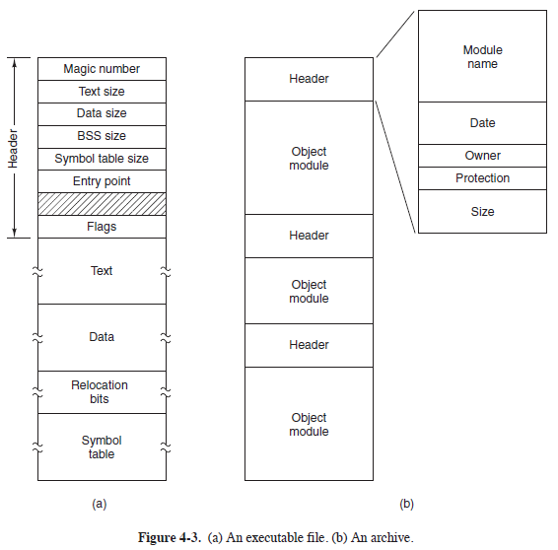  
  magic num = exec bit

**File Attributes**

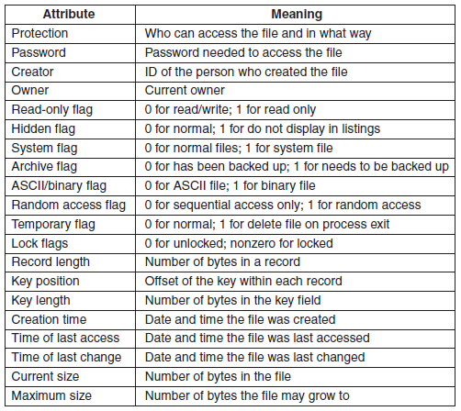

**File Ops**

* Create, Delete, Open, Close, Read, Write
* Append, Seek, get attributes, set attributes, rename

**Program to copy file**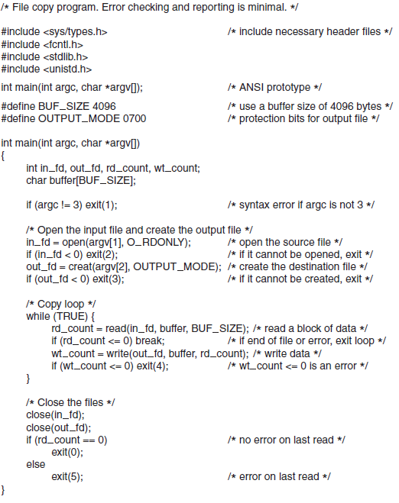

**Directory Systems**

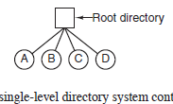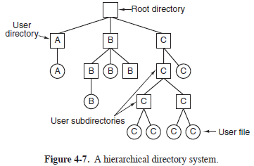

* Create, Delete, OpenDir, CloseDir
* ReAddir, Rename, Link, Unlink

**File System Layout**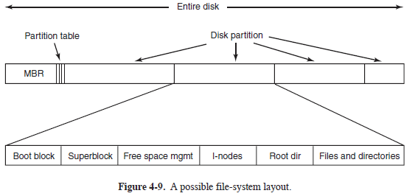

**Implementing Files (Contiguous Layout)**

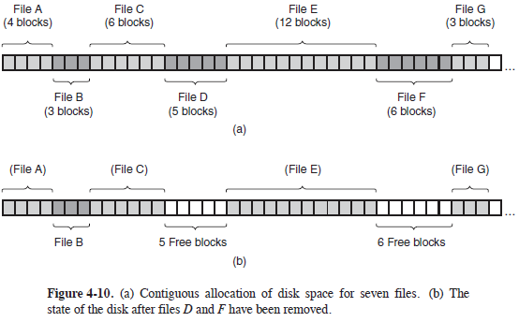

* (simple, fast reads)
* (fragmentation)

e.g. CD-Roms, DVD, BlueRay

**Implementing Files (LinkedList Layout)**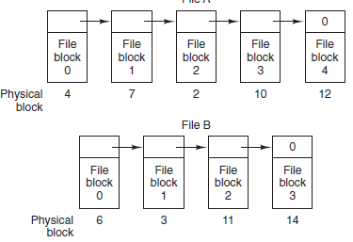

* No interfile fragmentation
* sequential reads = simple
* random access = very slow
* Data storage is not power of 2 (pointer takes up space, R/W based on 2 bytes)

**Implementing Files (LinkedList with table in mem)**File allocation table (FAT), MSDOS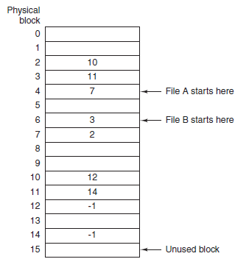

* Whole block is available for data
* Random access is quicker
* Entire table in memory (cannot scale well)

**Implementing Files (inode)NTFS**

Data struct listing attrib and disk address of file’s blocks

* In memory if corresponding file = open
* Does not depend on disk size
* Chain of inodes = necessary for big files

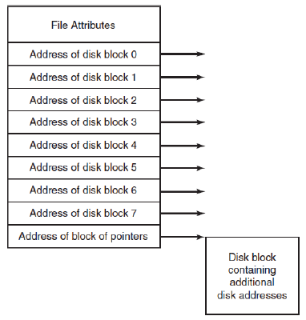

**Implementing Directories**Dir with Fixed size entries

1. Dir with entry to i-node

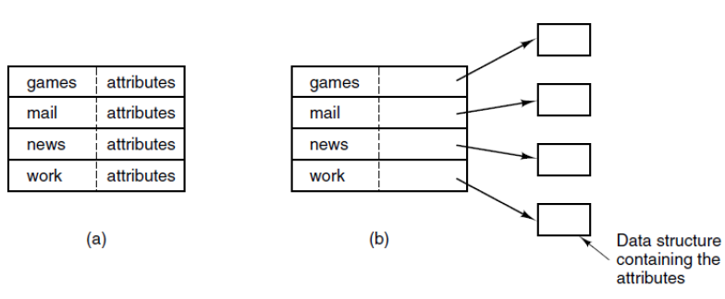

**File names**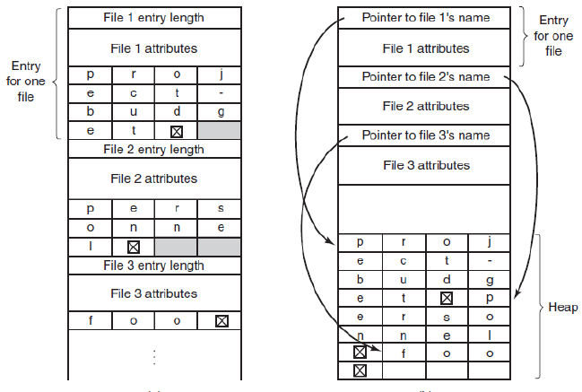

**Virtual File Systems**

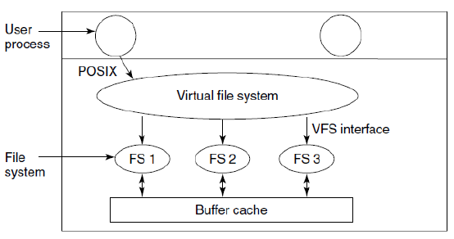

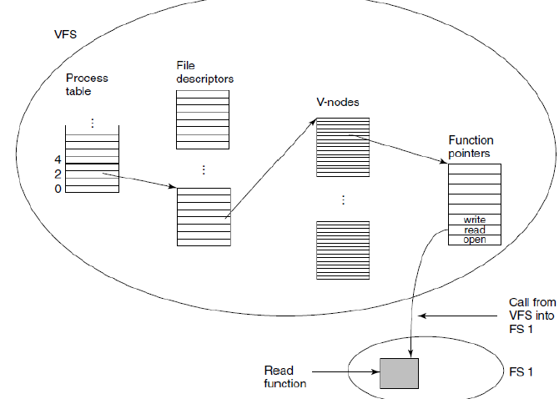

**Disk Quotas (quota table)**

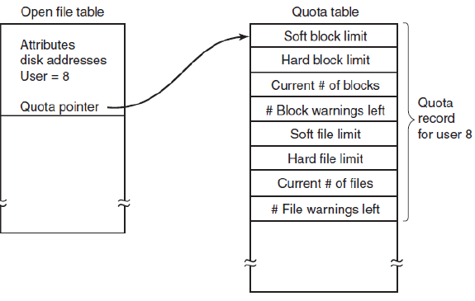

**MSDOS File System**

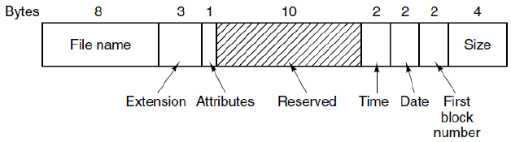

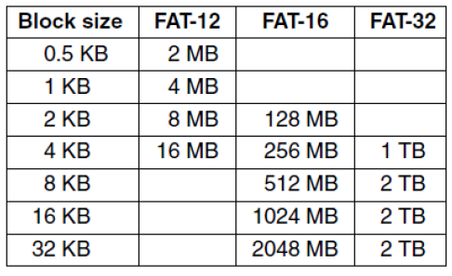

**Unix V7 File System**

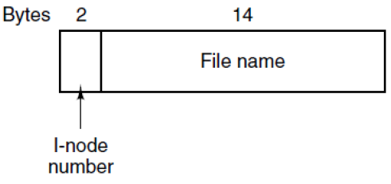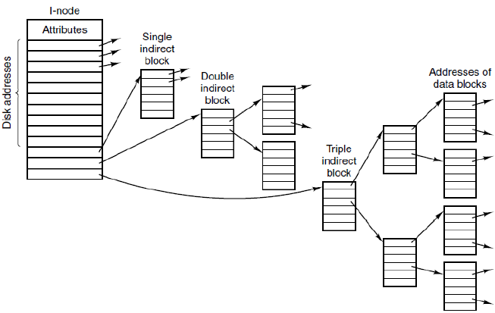

**Access a file in /usr/ast/mbox**

Go to **/** get & go to inode, find **usr**, …

ISO9660 File System

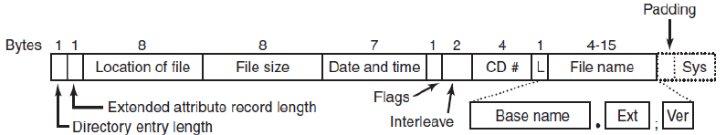

**Others (Rock Ridge & Joilet Extensions)**

* Longer name, Unicode, directory nesting higher level, directory name with extensions

**UNIX Shell**

Shell = command line interpreter

* programming language
* num of set instructions
* access to programs
* allows control flow
* standard I/O, error

Diff type available: sh, bash, zsh

Prompt = set of commands, waiting for cmd

Enter Key =

1. shell creates child process to run chosen program
2. process is running, shell waits for it to terminate
3. ****

Running in the BG

Use ampersand (&)

**I/O Redirection**using > to redirect output

Using < to redirect input

Using 2> to redirect error

Using | (pipe) to connect output of a program to input of another program

**Environment Variables**

Set and maintained until logout (or use config file)

SHELL=/bin/bash

Use “env” command or echo $VARNAME

Use export VAR=VALUE (whole session)

**Shortcut**

TAB = completions

CTRL-R = reverse search through prev used command

CTRL-C = Kill current process

CTRL-D = exit the current shell/issue EOF

CTRL-Z = suspend process (bg, fg to resume)

Wildcard

Special characters used in context of shell commands

? = any single character

* = any string (including empty

[] = ****

Regex

Pattern matching

CS…. = CS1234

**Shellscript**

Need to give execute permission chmod u+x hello.sh

Scripts can have variables

Name=value, access via $name

Special variables

$# = num of parameters

$0 = script name

$1/$2 = first/second parameter

$@ = all parameters

$? = exit value of last command

[ $myvar = “test” ] condition brackets (must have space)

= compare

CASE = definition of several scenarios

case $VAR in

Short)

Esac

If […], then, elif, fi

For varname in list, do, done

While […] do done

Read (scanner)

**C Programming intro**

/* Comment describing the file */

Include statements

#include – link file

Preprocessor definitions

#define TRUE 1

Function prototypes

Int sum(int num1, int num2);

* Must create .h file to be included

Global variable declarations

* Char, short, int, long
* Float, double, long double
* Void – no type specified
* Boolean = 1/0

Main function { … }

Other function { … }

**Console I/O**

Stdout/stdin

Puts(string), putchar(char) to print to stdout

Char = getchar() (get from stdin string)

Printf(format, var1, var2, var3)

Scanf(“%s”, &string);

Array

* fixed size
* array length not checked (no exception)

**C Programming**

Passed by value during call

Passed by reference (pointer)

Pointer = var that contains address of another var

* Can lead to more compact & efficient

P = &c; &= unary operator gives address of var c

*p = it will be a pointer that will point to a variable.

P = content of P (which is the address)

*p = the content of what p points to

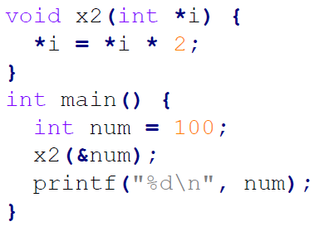

Pointers allow functions to change the value of var from the caller’s context

Use & to pass the address of the car

Use * to access the value of the address

Works with array too.

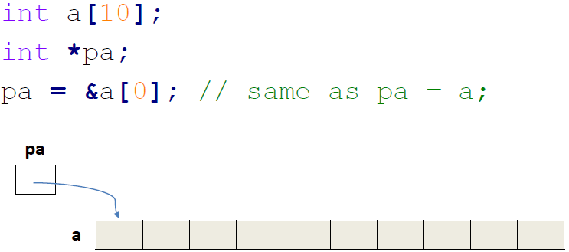

Pointers can be arithmetic

Int *pa;

pa = &a[0];

pa+1 will point to &a[1]; (pa++ is same too)

However, a = pa, and a++ are illegal, cos an array and a pointer variable are not fully equivalent

Files

Access file = requires opening them

Fopen = returns the pointer

Fclose = takes the file pointer, release the file

FILE *fopen(char *name, char mode)

Name = file name

Mode = r w a (append)

Different calls to read the different files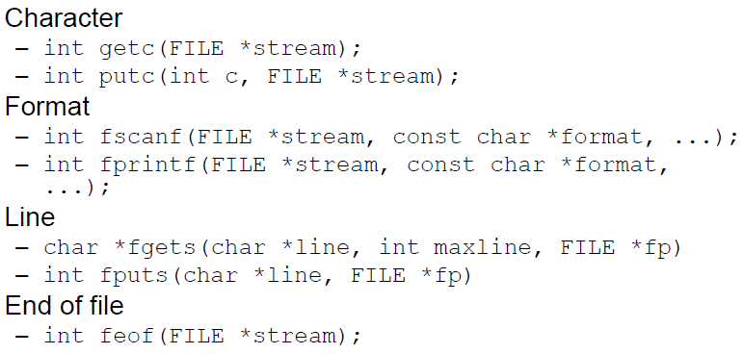

Binary file access use different calls

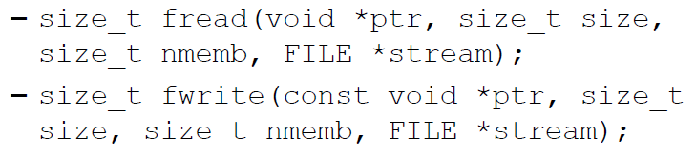

**Struct**

= group var of diff types

*Struct point {  
int x;*

*Int y;*

*}*

Declaring struct 2 ways:

* *Struct {…} s1;*
* *Struct point s1;*

Initialize:

* *Struct point mypoint = {1,2};*

*Point.x = 600;*

Can hold other structures or pointers too.

*Struct client myclient;*

*Struct client *pc = &myclient;*

Accessing a struct member from a pointer to a struct:

*(*pc).c_name*

*Pc->c_name*

Struct can self-ref too (linkedlist)

Struct can have pointer to another struct

**Unions**

= hold elements of diff types and sizes, but one element at a time

Allows saving space if element, can be diff types

Syntax and access are like the struct

*Union value{*

*Short s;*

*Int I;*

*}*

**Typedef**

Special keyword allows creating shortcuts for types

**typedef** int km_per_hour ;

**typedef** int points ;

km_per_hour current_speed ; *//"km_per_hour" is synonymous with "int" here,*

points high_score ; *//and thus, the compiler treats our new variables as integers.*

void congratulate(points your_score) {

**if** (your_score > high_score)

**Static vs Dynamic**

Static memory (above) Dynamic memory (below)

**Malloc(size_t size);**

Allocates block of memory in the heap (with size)

RET type = pointer to void.

* Generic pointer
* Pointer cast to required type

Dynamically create an array of n ints

*Int *myints = malloc(n * sizeof(int));*

*Int *myints = malloc( sizeof *myints);*

**Calloc**

* Allocates and zero-initialize a no. of mem block

**Realloc**

* Change the size of prev allocated memory

NULL = allocation failed

**Free memory**

Needs to be explicitly freed with *free*

**Memory Leaks**

* A block of allocated mem no longer referenced by a pointer that cannot be freed
* Alloc twice to the same pointer
* First one alloc alr, but cannot free

Stack = local var, parameters, RET

Heap = dynamically allocated elements

**Buffer Overflows**

* Attempt to write data past the boundary of array
* Cause a crash, cos iillegal region
* Change critical data, change EIP

**Preventing buffer overflow**

* Use memory audiing tools like valgrind
* Use limited charater length string functions such as strncpy and strncmp instead of strcpy and strcmp
* Fgets instead of gets

**Deadlocks**

Resources used by 1 proc at a time, OS needs to grant access

**Preemptable/nonpreemptable resources**

**P** = can be taken away temporarily

**NP =** cannot be taken away temporarily or will fail (burn DVD)

Semaphores to protect resources

Potential Deadlock (locking resources in different order)

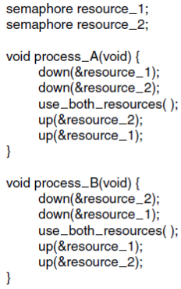

**Set of processes = deadlocked IF:**

* Each process waiting for event
* Event can only be caused another process in set

**4 conditions for deadlock**

* **Mutual exclusion**
* **Hold and wait (hold R and waiting for new R)**
* **No preemption**
* **Circular wait condition**

**Deadlock Modelling**

Process = circle , square = resource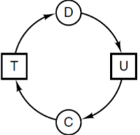

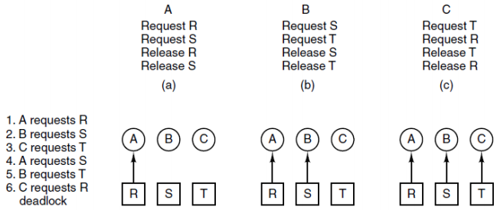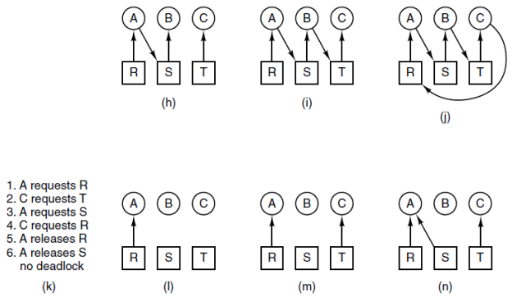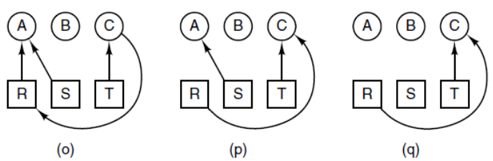

**Strategies**

1. Detection and Recovery
2. Dynamic avoidance be careful resource allocation
3. Prevention, negating 1 of 4 conditions

**Detection and Recovery**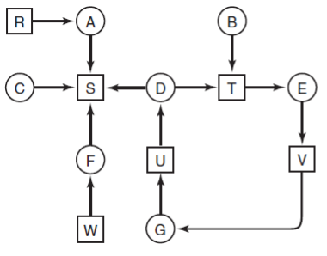

Algo

For all nodes, follow all the nodes movement and see it if goes back to itself (detect cycles)

Detection for Multiple R of Each Type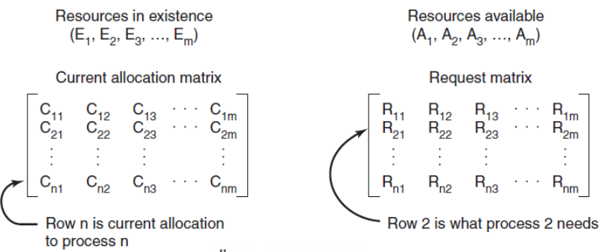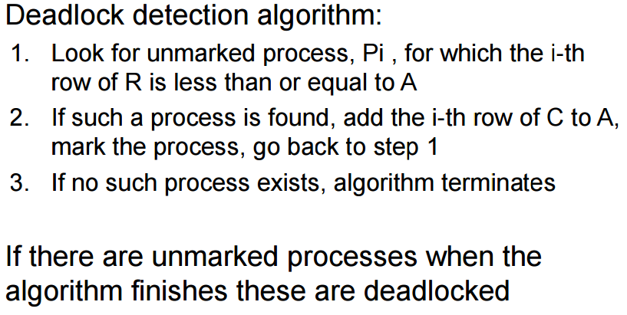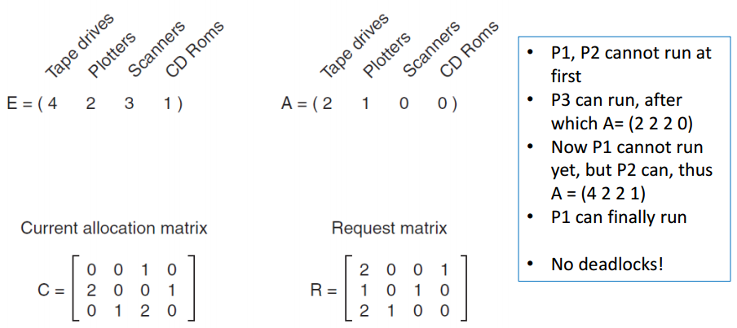

**Recovery**

1. **Preemption** (dependent of nature of resource)
2. **Rollback** (save state, RB to state bef. Deadlock)
3. **Killing proc** (break the deadlock)

**Deadlock Avoidance**

**Resource trajectories**

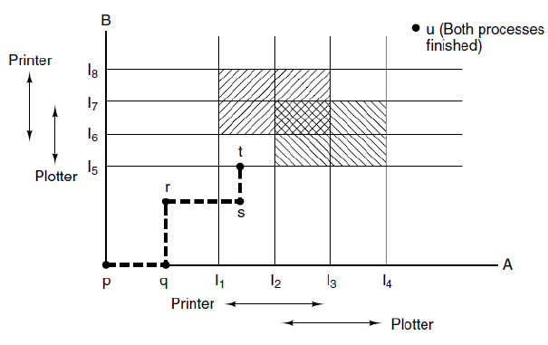

**Safe and Unsafe States**

System can guarantee that all proc will finish

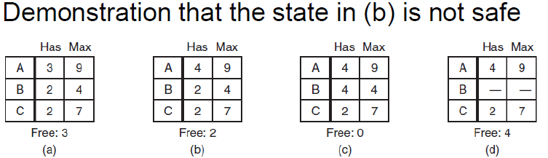

**Banker’s Algorithm for multiple resource**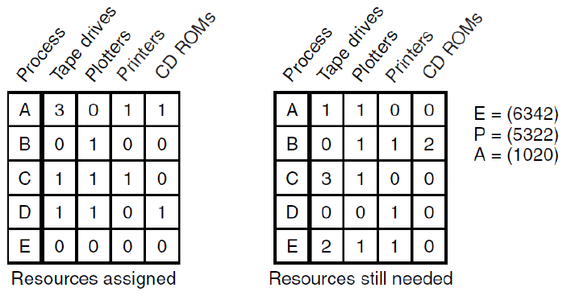

**\*diff =** has the “max resources” that the proc will req, so can know if safe or unsafe state

**Deadlock Prevention**

**Deadlock avoidance** = only if detailed information about future (not common)

**Deadlock prevention** = more realistic

* Ensure 1 of 4 deadlock conditions never satisfied
* Mutual exclusion – avoiding assigning resource unless absolutely necessary
* Hold-wait = requires all proc to request all resources before starting execution (but many proc do not know how many resources they need at start)
* No-Preemption = not all fit that category (db, needs to be locked to be used)
* Circular wait
  + Request need to be made in numerical order (then no cycle)

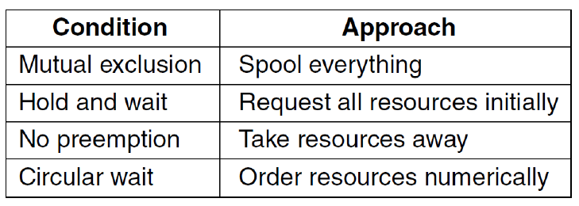

Spool everything = printer spooler (queue)

**Communication Deadlocks**

* Resource deadlock in **network**
* 

**LiveLock**

* Processes not blocked, but no progress
* 

**Starvation**

* Never have chance to use resource
* Solved by algo (1st come 1st served)

**9.1 Unix**

Goals

* Simplicity, elegance, consistency
* Power + flexibility
* Lack of useless redundancy

Layers

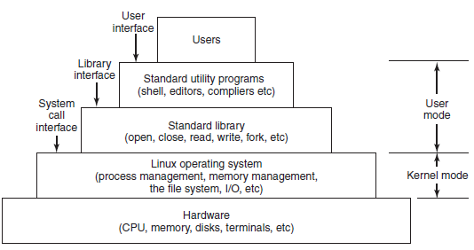

Shell

* CLI (Faster, powerful, extensible)
* Shell scripts…

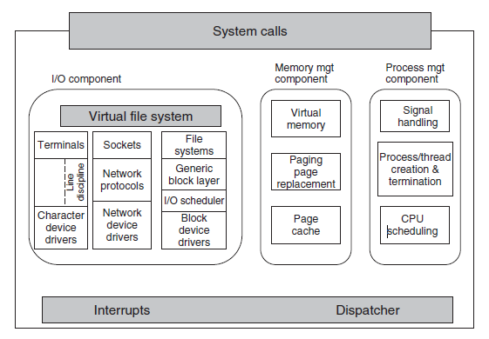

**Signals**

Communicate P – P, OS -P

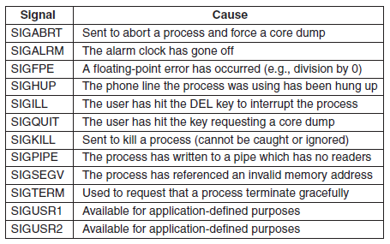

**System Calls**

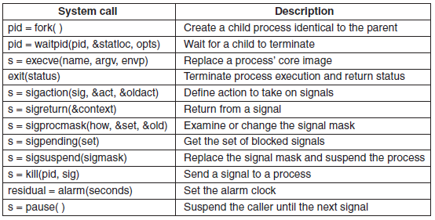

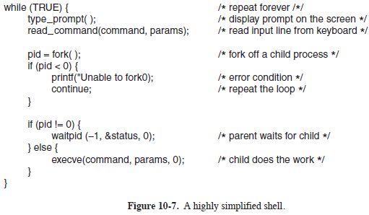

**Implementation of Processes and Threads in Linux**

* Process descriptors
  + Scheduling params
  + Memory image
  + Signals
  + …

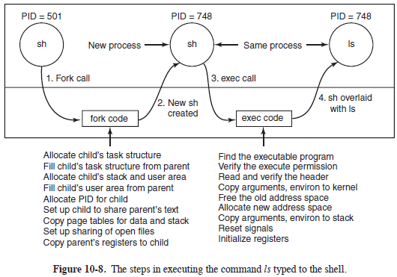

**Threads in Linux**

* Special call: **Clone**
* Clone: create new thread with in current process,or new process (depending on flag)
* 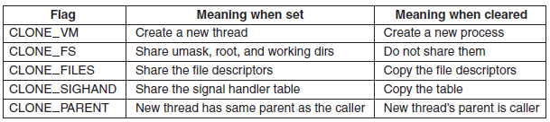

**Scheduling**

* Threads are kernel threads (scheduling based on threads, not processes)
* 3 classes of threads for scheduling
  + Real-time FIFO
  + Real-time Round Robin
  + Timesharing
* 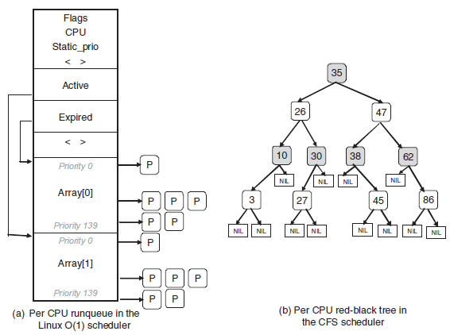
* **(a)Disadv O(1)**
  + Priority not taken in consideration
* **O(log(N))**

Completey Fair Scheduler(CFS)

Schedules least amount of time on CPU first

Memory

Text, data segment, uses .BSS

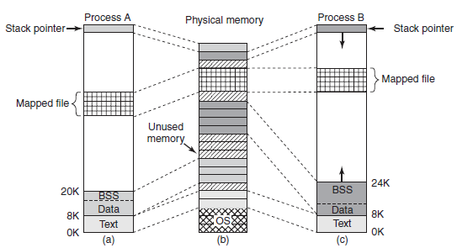

*2 process can share a mapped file

Syscalls memory management

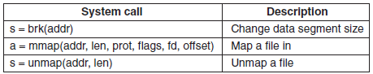

Physical Memory Management

1. **ZONE DMA** and **ZONE DMA32**: pages that can be used for DMA.

2. **ZONE NORMAL**: normal, regularly mapped pages.

3. **ZONE HIGHMEM**: pages with high-memory addresses, which are not permanently mapped.

First 2 (kernel and memory map) pinned in memory

Rest divided into page frames

Page Tables in Linux

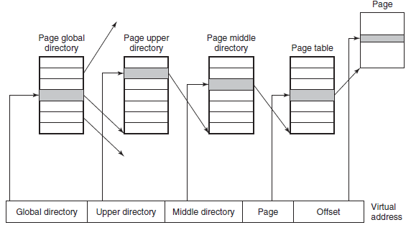

**Memory Allocation Mechanism**

Main mechanism of allocating new page frames = page allocator ( buddy algorithm)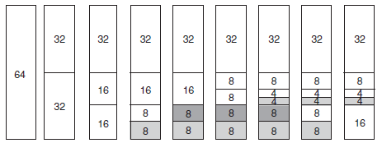

Power-of-2

Disadv = if wants 65, needs 128-page chunk

Therefore, slab allocator (carves slabs from the big chunks)

3rd one, vmalloc (if doesn’t needs to be contiguous in physical memory, contiguous in virtual only)

**Paging in Linux**

Use page daemon

Full demand-paged sys, no prepaging, no working-set

Text segment & mapped files, paged to respective files on desk

Swap area

**Page Replacement Algo**

= PFRA (Page Frame Reclaiming Algo)

Tries to keep some pages free so that they can be claimed as needed.

4 types of pages:

* Unreclaimable (reserved/locked)
* Swappable – written back to swap before being reclaim
* Syncable – written back to disk, if only marked as dirty
* Discardable – reclaimable immediately

Replace the easy ones first, the proceed with hard ones

(put inside zone’s freelist)

Uses clock-like algo to select old pages for eviction.

Tries to reclaim with diff urgencies values (how much effort to reclaim)

I/O in Linux

= “everything is a file”

Block special files (used for disks)

Character special file = process I/O

Networking

* Use of sockets for networking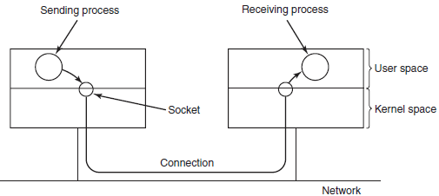

I/O implementation

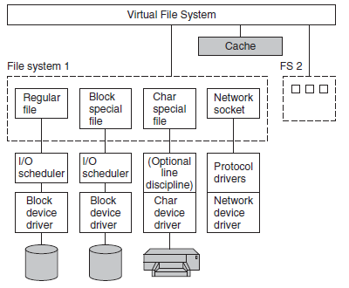

LFS

* Locking (prevent race cond)
* Exclusive locks (1 lock, other locks will fail)
* Shared locks (allow shared locks, not exclus)

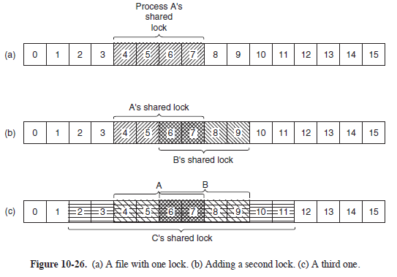

File sys abstraction VFS by linux

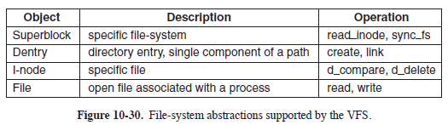

Disk layout of ext2 FS

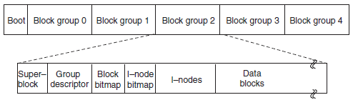



**NFS Architecture**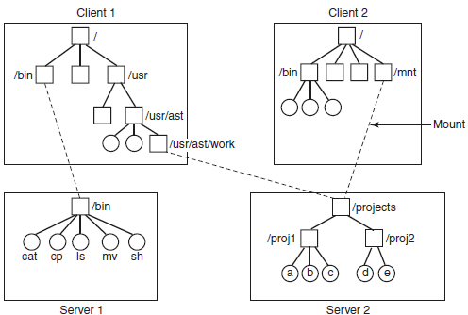

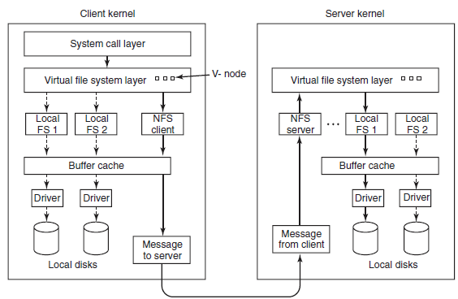

SETUID and SETGID protection bits (run as the owner of file, instead of runner)

Android

Goals:

* Support mobile user interaction
* Manage app processes for users
* Full OS
* Collab, interoperate

Dalvik (JRE)

Zygote (daemon root, core OS services)



New Dalvik process



Wake locks (suspend blockers)

* Idle = more power than true sleep
* Wake up any moment
* Does not tell u that u can turn off other hardware

Binder IPC



Userspace object-oriented lib

Binder = concrete Binder object

Parcel = container for reading/writing data in binder transaction

APK

* Manifest (what it does, how to run)
* Resources
* Code
* Signing info

Activity

* Part of app that interacts with user through UI

Services

* Long running process or API

**Windows**

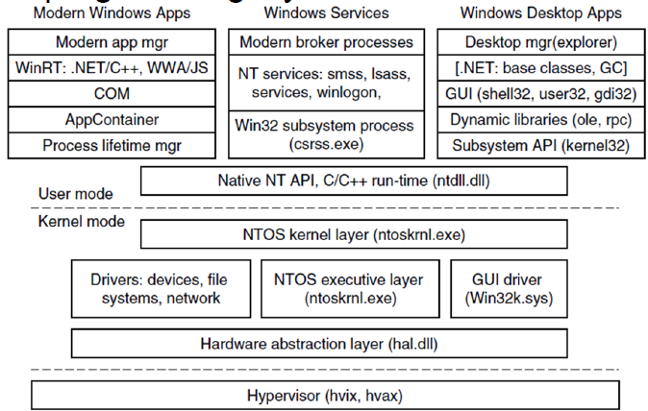

**Uses registry** (organized into separate volumes), hives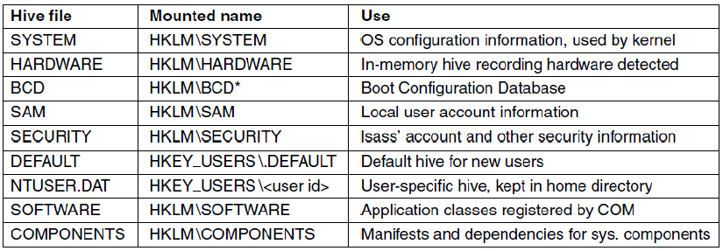

**OS Structure**

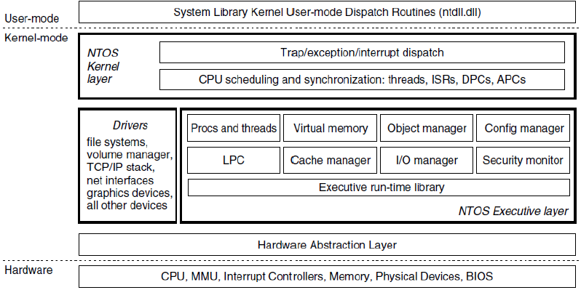

**Hardware Abstraction Layer**

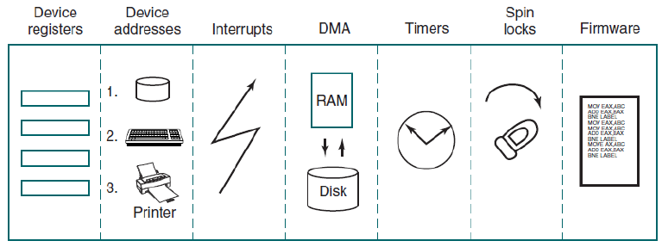

**Jobs, Processes, Threads, Fibers**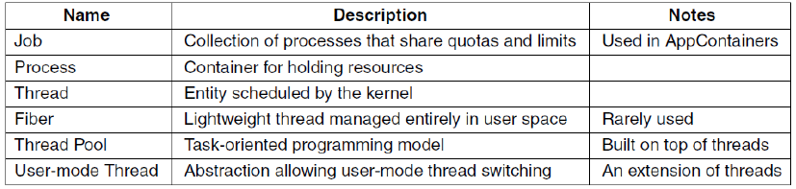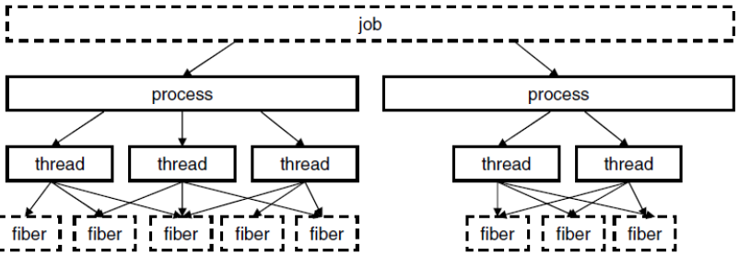

**Difference from unix**

* Actual search path for finding program (buried in lib for win32, managed more explicit in UNIX)
* Working Dir in Unix, User-mode string in WIN
* Win32 program parse args, UNIX parse cmd line and passes array of parameters.
* New process pass info to GUI directly in WIN, passed as param to GUI in UNIX
* Windows doesn’t have SETUID, but one proc can create proc that runs as different user
* Proc and thread handle can use to modify spawned threads in many ways in WIN. Only can make modification between fork and exec calls in limited ways in UNIX

**Scheduling**

No central scheduling thread

Thread cannot run – calls scheduler

Conditions:

* running thread with mutex
* thread signals object
* quantum expires
* i/o operation completes
* timed wait expires

Uses priorities, threads have relative priority

32 priorities

Head of queue selected (run for 1 quantum)

Quantum expires, goes next

Goes round-robin, for 1 quantum each

**Memory Management**

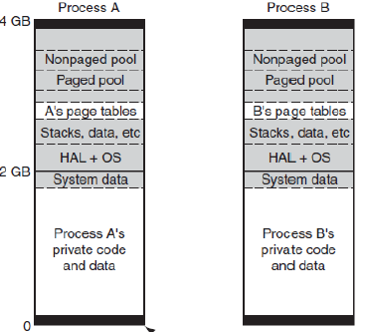Grey = shared, white = private

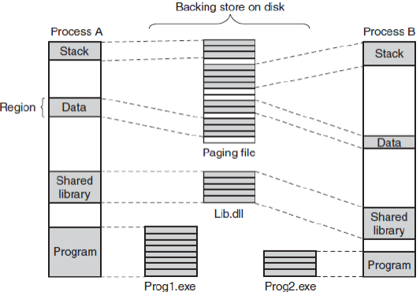

Page fault handling

* uses a page table entry (PTE)

Categories

* page reference not committed
* attempt access to page (unauthorized)
* shared copy-on-write page (to be modified)
* stack needs to grow
* page reference committed, not mapped

Page Replacement Algo

3 scenarios

* Lots of memory
  + Keep an age of each page, estate unused pages in each working set
* Memory getting tight
  + Significant proportion of unused pages, stop adding pages to working set, replacing oldest with new. Replace – standby list
* Memory is tight
  + Trum working sets to below their max, remove oldest page.

**Physical Memory management**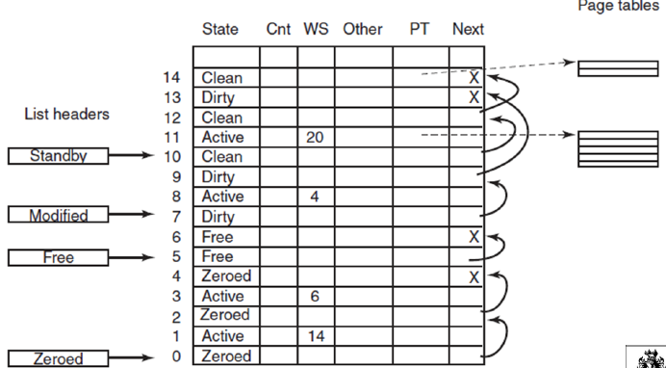

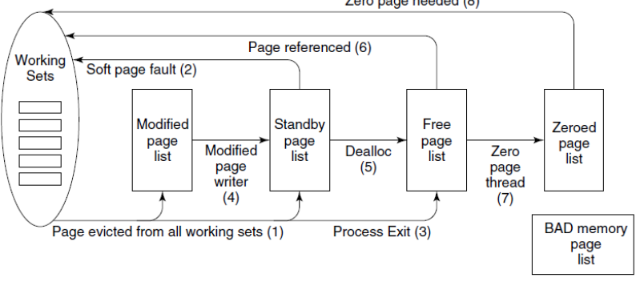

**Device Drivers**

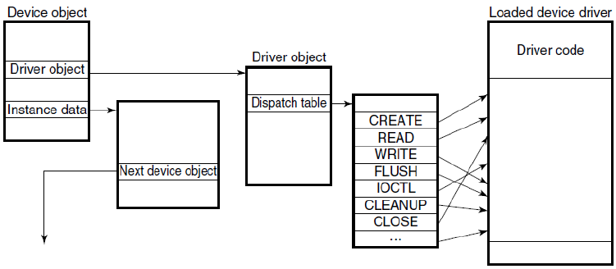

I/O Request

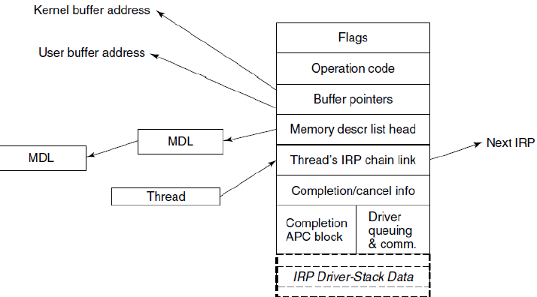

**Security**

Inherited from NT:

* Secure login with antispoofing
* DAC
* Privileged AC
* Address space protection
* New pages = zero, before mapping
* Security auditing

**Virtualization**

Common to have multi computers

* separation = distribute load, reliable, multiple OS
* expensive, maintenance/support

**Virtualization = solution**

**Hypervisors**

**Requirements:**

Safety: full control of virtualized resources

Fidelity: app must behave same in vm and hardware

Efficiency: app in vm should run without intervention

2 types: runs on bare metal, uses services of OS

Techniques for efficient virtualization

(VT virtualization technology, special instruction set) 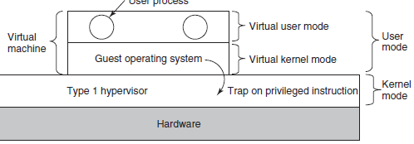

If no VT

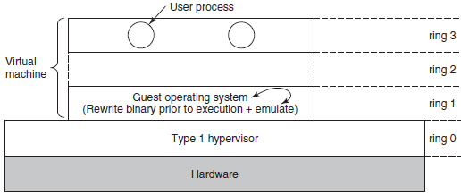

**Cost of VT**

Execution directly in hardware many times outperforms software layer

However VT- trap and emulate generate many traps, quite expensive

* ruins CPU cache, TLB, branch prediction tables

Translation sensitive instructions by calls to HV = does not incur context-switching overhead

Depending on workload, software might beat hardware

Hypervisor can do BT(binary translation as well for performance)

**Hardware wins Software**

**Hypervisors Microkernels**

True virtualization and paravirtualization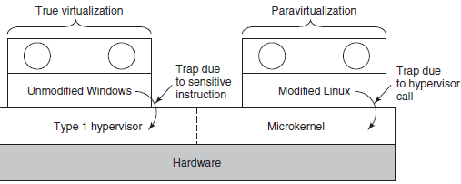

Virtual Machine Interface (VMI)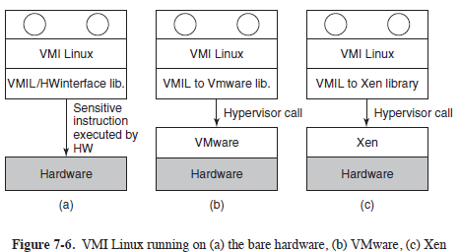

Virtual memory = poses a problem to memory virtualization

* VM do not have access to each other VM mapping
* HV create shadow page table that maps virtual pages to the actual one given

Hardware Support for nested page table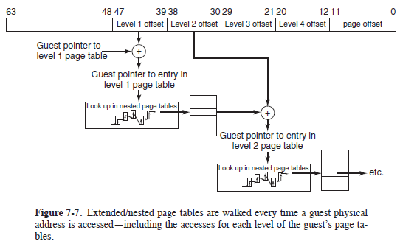

**I/O**

Transparent: has issues, OS will think they have entire disk

* Gives disk partitions, or use files

Networking

* Use it as a switch

Virtual Appliance

* Shrink-wrapped VMs

Licensing issue

* Not clear

Cloud

* Virtualize environment

Cloud

* On demand self-service
* Broad network access
* Resource pooling
* Rapid elasticity
* Measured service

Cloud = IAAS Infrastructure as a service

Hypervisor decouple VM from physical hardware (live migration)